In this model I chose

'Distance' ,'Postcode' ,'Bedroom2','Bathroom','Landsize' ,'BuildingArea' ,'YearBuilt','Lattitude','Longtitude'

As my other attributes which would help for finding the price as our resultant attribute .The reason why I chose it because i plotted each attribute and plotted against our resultant attribute ;price’ ,and from each of attribute I understood dependency between the attribute with the resultant attribute .The graphs of some of these are shown here :

Lattitude on price

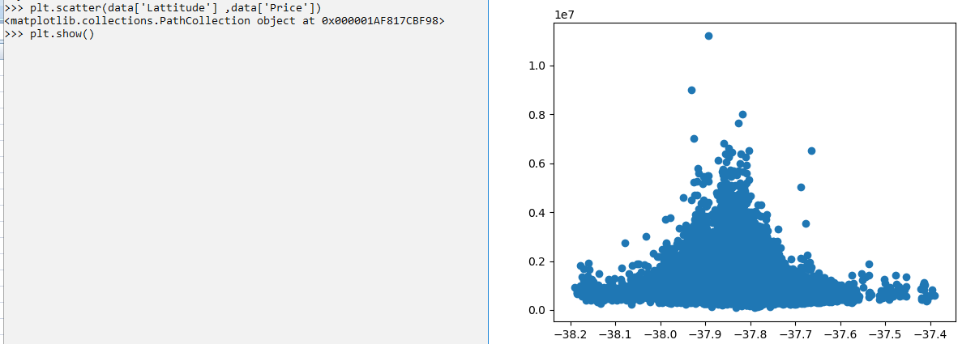

Building area on price

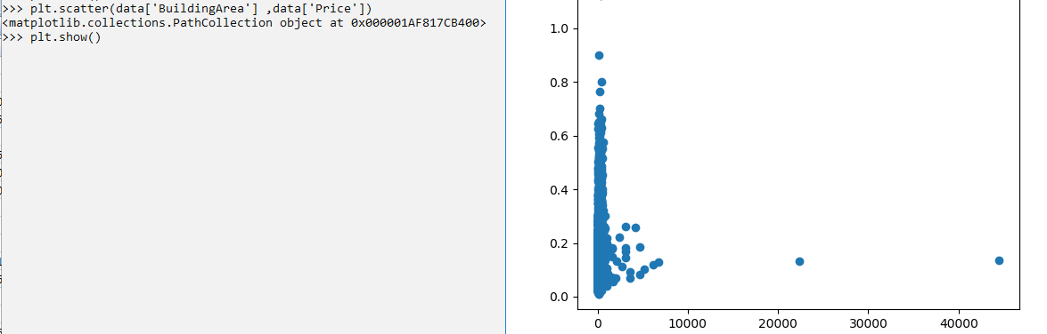

Thus imagining linear regression we can find that a straight line can be drawn through all maximum points ,hence I selected these attributes.